Measurement Protocol PAX

# General Information:

|  |  |  |
| --- | --- | --- |
| Test date: 19/02/20 | Date prev. test: | Test number: 1 |
| Tested by: Alex Pollak | PAX number: PB-012 | Installed at ant.:1A |
| Comments: Revision: 1.10 pax controller | | |
|  | | |
|  | | |
|  | | |
| Known problems: | | |
|  | | |
|  | | |
|  | | |

# Setup:

|  |  |  |  |
| --- | --- | --- | --- |
| Power supply: | OK 🗹 NOK 🗆 | Communication: | OK 🗹 NOK 🗆 |
| Supply current +6V: 1.108A | | ssh obs@antcntl | |
| Supply current -6V: 0.131A | | ssh ataant@paxtester | pw: q@n@t |
| Supply current +5V: 0.197A | | telnet pax | “help” |
|  | | CTRL + ] | “close” |

# RF Test with VNA:

### VNA Setup:

|  |  |  |
| --- | --- | --- |
| Load configuration: Passband_PAX.csa | | |
| Freq Start: 1.0 GHz | Freq Stop: 13.0 GHz | Power Level: -20 dBm |
| Averaging: enabled | Averaging count: 15 | N. Points: 801 |
| VNA : Agilent N5230C 10MHz - 20GHz | | |

|  |  |  |  |  |
| --- | --- | --- | --- | --- |
| VNA to PAX connection: | 1m ABC-CA18 Cable + 20dB Attenuator | | | |
| Input Power Level to PAX: (Measured) | @1GHz:  -40.2dBm | @4GHz:  -40.7dBm | @8GHz: -41.2dBm | @12GHz: -41.4dBm |

|  |  |
| --- | --- |
| PAX to VNA connection: | 2m Fibre Cable + Fibre Diode + AOX Amplifier + 1m ABC-CA18 Cable |

### Measured Passband with Attenuator set to 7dB each (Complete Link):

|  |
| --- |
| X |

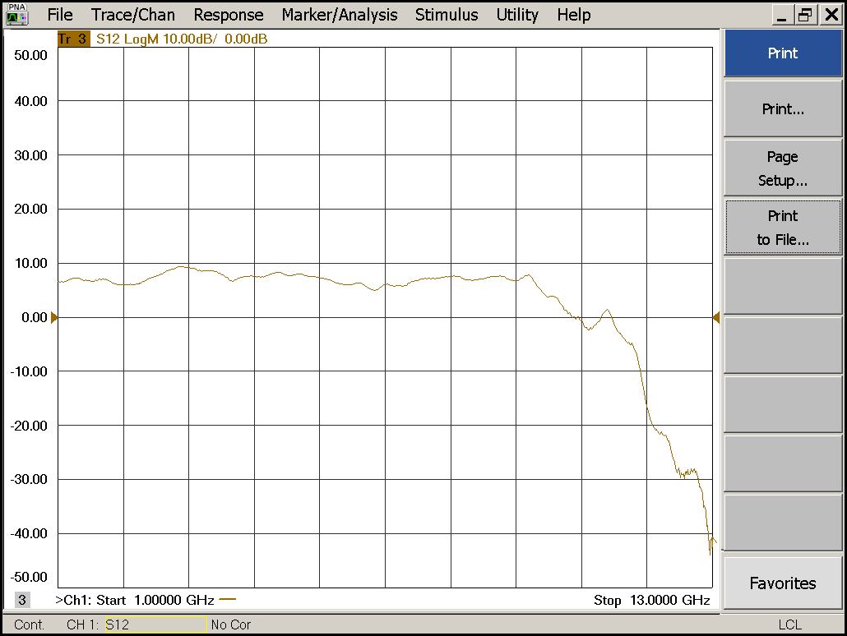

|  |  |  |  |
| --- | --- | --- | --- |
| Flatness: | OK 🗹 NOK 🗆 | Unwanted Features: | Yes 🗆 No 🗹 |

|  |
| --- |
| Y |

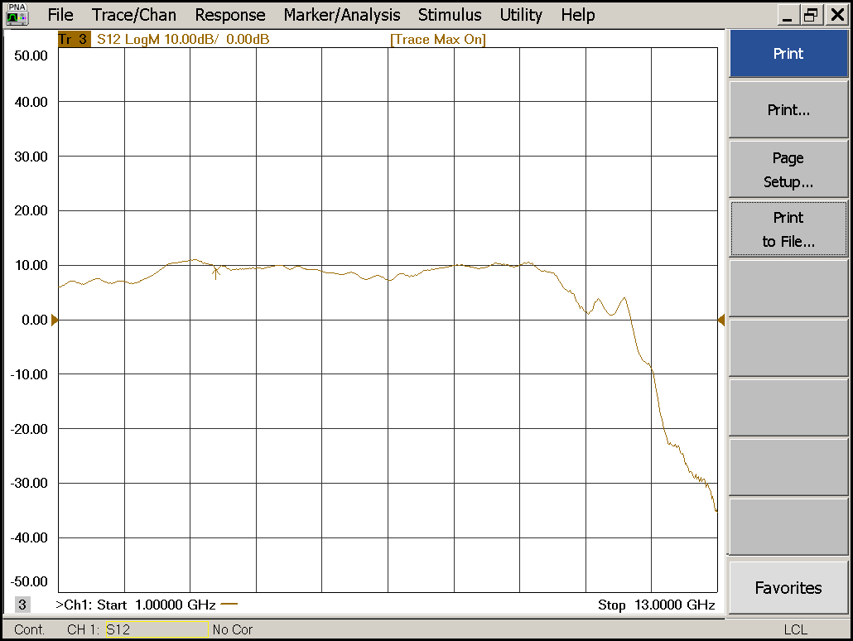

|  |  |  |  |
| --- | --- | --- | --- |
| Flatness: | OK 🗹 NOK 🗆 | Unwanted Features: | Yes 🗆 No 🗹 |

### Power Sweep (Complete Link):

|  |  |  |
| --- | --- | --- |
| Load configuration: Power_Sweep_PAX.csa | | |
| Power Start: -40dBm | Power Stop: -20dBm | Frequency : 4.0GHz |
| PAM Attenuator: 0dB |  | N. Points: 801 |

|  |
| --- |
| X |

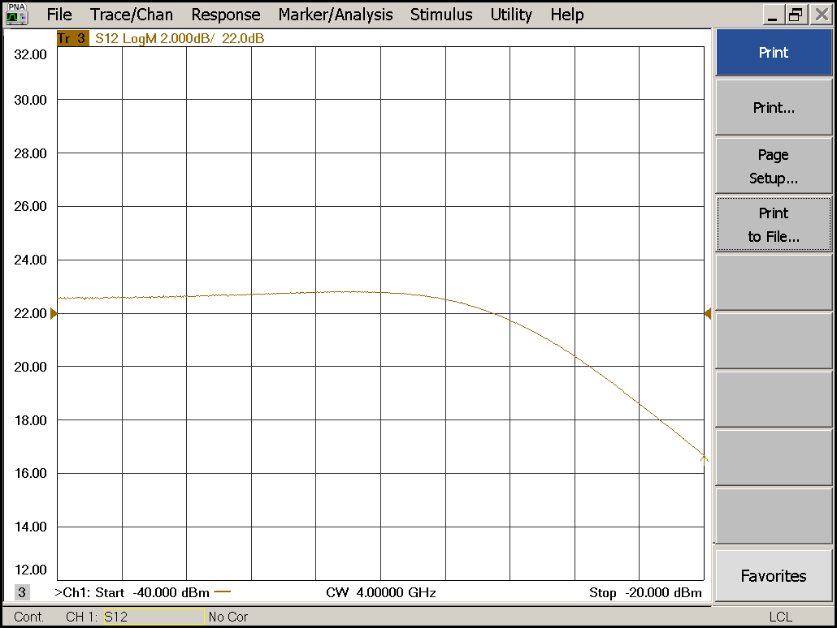

|  |  |  |  |
| --- | --- | --- | --- |
| Compression point: | OK 🗹 NOK 🗆 | Unwanted Features: | Yes 🗹 No 🗆 |

|  |
| --- |
| Y |

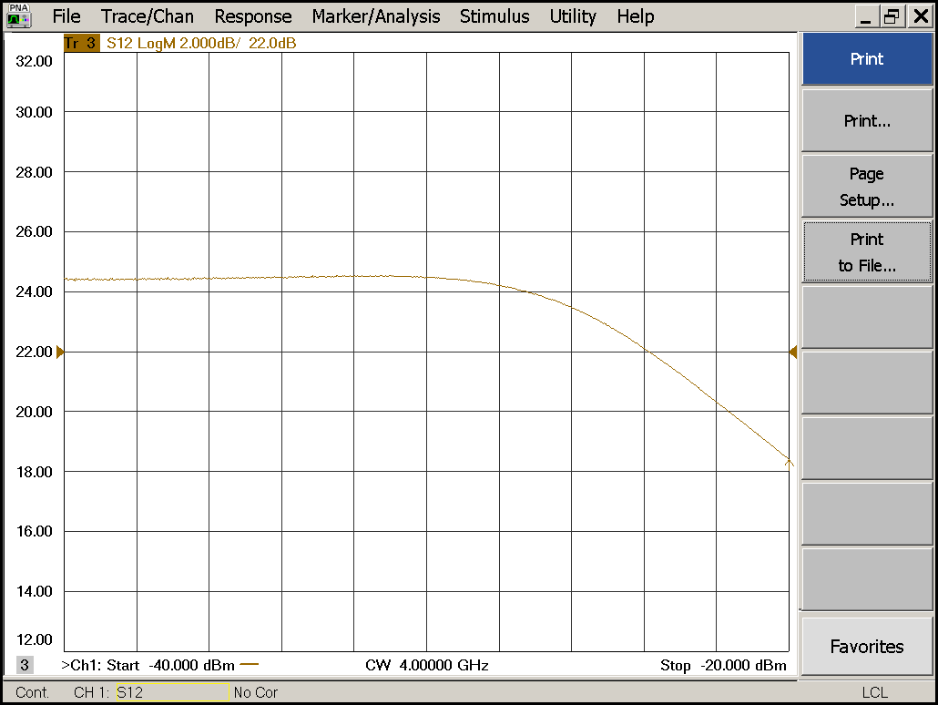

|  |  |  |  |
| --- | --- | --- | --- |
| Compression point: | OK 🗹 NOK 🗆 | Unwanted Features: | Yes 🗹 No 🗆 |

### Detector Calibration and Attenuator Sweep Pol X:

|  |  |  |
| --- | --- | --- |
| Load configuration: Detector_Calibration_PAX.csa | | |
| Freq : 4.0 GHz | Power Level: -20dBm | Sweep Time: -20sec |
| Sweep Mode: CW | Power Level at PAX Input (Measured): -40.6dBm | |

|  |  |  |  |  |
| --- | --- | --- | --- | --- |
| X | | | | |
| CW Input Power [dBm]: | Attenuator Value A [dB]: | Attenuator Value: B [dB]: | Detector Value: | Power Meter  Value [dBm]: |
| -40.6 | 0 | 0 | - | 14.3 |
| -40.6 | 0 | 3 | - | 14.2 |
| -40.6 | 0 | 6 | - | 12.8 |
| -40.6 | 0 | 9 | 0.8589 | 10.1 |
| -40.6 | 0 | 12 | 0.6506 | 7.1 |
| -40.6 | 0 | 15 | 0.3939 | 4.2 |
| -40.6 | 0 | 18 | 0.2137 | 0.9 |
| -40.6 | 0 | 21 | 0.1170 | -2.2 |
| -40.6 | 3 | 21 | 0.0582 | -5.4 |
| -40.6 | 6 | 21 | 0.0308 | -8.3 |
| -40.6 | 9 | 21 | 0.0162 | -11.3 |
| -40.6 | 12 | 21 | 0.0089 | -14.1 |
| -40.6 | 15 | 21 | 0.0050 | -17.1 |
| -40.6 | 18 | 21 | 0.0029 | -20.3 |
| -40.6 | 21 | 21 | 0.0020 | -23.3 |
| -40.6 | 24 | 21 | 0.0015 | -26.2 |
| -40.6 | 27 | 21 | 0.0013 | -29.2 |
| -40.6 | 30 | 21 | 0.0012 | -32.3 |
| -40.6 | 30 | 24 | 0.0011 | -34.9 |
| -40.6 | 30 | 27 | 0.0011 | -37.5 |
| -40.6 | 30 | 30 | 0.0011 | -39.9 |

|  |  |  |
| --- | --- | --- |
| Use Noise Source: Atlantic AS6333 | | |
| Freq : 1.0 - 12.0GHz | Power Level: -41.8dBm |  |
| DC Supply: 28V |  | |

|  |  |  |  |  |
| --- | --- | --- | --- | --- |
| X | | | | |
| Input Power [dBm]: | Attenuator Value A [dB]: | Attenuator Value: B [dB]: | Detector Value: | Power Meter  Value [dBm]: |
| -41.8 | 0 | 0 | - | 12.1 |
| -41.8 | 0 | 3 | - | 10.7 |
| -41.8 | 0 | 6 | - | 8.8 |
| -41.8 | 0 | 9 | 0.8583 | 6.4 |
| -41.8 | 0 | 12 | 0.7143 | 3.6 |
| -41.8 | 0 | 15 | 0.4456 | 0.9 |
| -41.8 | 0 | 18 | 0.2420 | -2.2 |
| -41.8 | 0 | 21 | 0.1339 | -5.2 |
| -41.8 | 3 | 21 | 0.0718 | -8.2 |
| -41.8 | 6 | 21 | 0.0371 | -11.2 |
| -41.8 | 9 | 21 | 0.0197 | -14.1 |
| -41.8 | 12 | 21 | 0.0105 | -17.0 |
| -41.8 | 15 | 21 | 0.0063 | -19.7 |
| -41.8 | 18 | 21 | 0.0036 | -23.1 |
| -41.8 | 21 | 21 | 0.0024 | -26.0 |
| -41.8 | 24 | 21 | 0.0018 | -29.0 |
| -41.8 | 27 | 21 | 0.0017 | -31.8 |
| -41.8 | 30 | 21 | 0.0014 | -34.9 |
| -41.8 | 30 | 24 | 0.0013 | -37.4 |
| -41.8 | 30 | 27 | 0.0013 | -39.5 |
| -41.8 | 30 | 30 | 0.0013 | -41.4 |

### Detector Calibration and Attenuator Sweep Pol Y:

|  |  |  |
| --- | --- | --- |
| Load configuration: Detector_Calibration_PAX.csa | | |
| Freq : 4.0 GHz | Power Level: -20dBm | Sweep Time: -20sec |
| Sweep Mode: CW | Power Level at PAX Input (Measured): -40.6dBm | |

|  |  |  |  |  |
| --- | --- | --- | --- | --- |
| Y | | | | |
| CW Input Power [dBm]: | Attenuator Value A [dB]: | Attenuator Value: B [dB]: | Detector Value: | Power Meter  Value [dBm]: |
| -40.6 | 0 | 0 | - | 14.1 |
| -40.6 | 0 | 3 | 0.8513 | 13.9 |
| -40.6 | 0 | 6 | 0.8308 | 12.4 |
| -40.6 | 0 | 9 | 0.5838 | 9.8 |
| -40.6 | 0 | 12 | 0.3687 | 6.8 |
| -40.6 | 0 | 15 | 0.2332 | 3.9 |
| -40.6 | 0 | 18 | 0.1297 | 0.6 |
| -40.6 | 0 | 21 | 0.0753 | -2.5 |
| -40.6 | 3 | 21 | 0.0400 | -5.6 |
| -40.6 | 6 | 21 | 0.0209 | -8.6 |
| -40.6 | 9 | 21 | 0.0110 | -11.5 |
| -40.6 | 12 | 21 | 0.0059 | -14.5 |
| -40.6 | 15 | 21 | 0.0035 | -17.4 |
| -40.6 | 18 | 21 | 0.0021 | -20.6 |
| -40.6 | 21 | 21 | 0.0015 | -23.8 |
| -40.6 | 24 | 21 | 0.0011 | -26.6 |
| -40.6 | 27 | 21 | 0.0009 | -29.6 |
| -40.6 | 30 | 21 | 0.0008 | -32.7 |
| -40.6 | 30 | 24 | 0.0008 | -35.4 |
| -40.6 | 30 | 27 | 0.0008 | -38.0 |
| -40.6 | 30 | 30 | 0.0008 | -40.4 |

|  |  |  |
| --- | --- | --- |
| Use Noise Source: Atlantic AS6333 | | |
| Freq : 1.0 - 12.0GHz | Power Level: -41.8dBm |  |
| DC Supply: 28V |  | |

|  |  |  |  |  |
| --- | --- | --- | --- | --- |
| Y | | | | |
| Input Power [dBm]: | Attenuator Value A [dB]: | Attenuator Value: B [dB]: | Detector Value: | Power Meter  Value [dBm]: |
| -41.8 | 0 | 0 | - | 11.8 |
| -41.8 | 0 | 3 | - | 10.6 |
| -41.8 | 0 | 6 | - | 8.7 |
| -41.8 | 0 | 9 | 0.8516 | 6.4 |
| -41.8 | 0 | 12 | 0.5911 | 3.6 |
| -41.8 | 0 | 15 | 0.3968 | 1.0 |
| -41.8 | 0 | 18 | 0.2267 | -2.3 |
| -41.8 | 0 | 21 | 0.1336 | -5.2 |
| -41.8 | 3 | 21 | 0.0766 | -8.1 |
| -41.8 | 6 | 21 | 0.0398 | -11.2 |
| -41.8 | 9 | 21 | 0.0210 | -14.2 |
| -41.8 | 12 | 21 | 0.0109 | -17.2 |
| -41.8 | 15 | 21 | 0.0065 | -19.8 |
| -41.8 | 18 | 21 | 0.0035 | -23.2 |
| -41.8 | 21 | 21 | 0.0022 | -26.3 |
| -41.8 | 24 | 21 | 0.0016 | -29.4 |
| -41.8 | 27 | 21 | 0.0013 | -32.1 |
| -41.8 | 30 | 21 | 0.0012 | -35.4 |
| -41.8 | 30 | 24 | 0.0011 | -37.9 |
| -41.8 | 30 | 27 | 0.0010 | -39.9 |
| -41.8 | 30 | 30 | 0.0010 | -41.8 |

# Inspection:

### Visual:

|  |  |  |
| --- | --- | --- |
| Fibre Connectors Clean | Comments: | OK 🗹 NOK 🗆 |
| Fibre Connector Mechanical | Comments: | OK **🗹** NOK **🗆** |
| RF Cable | Comments: | OK **🗹** NOK **🗆** |
| RF Connectors Clean | Comments: | OK **🗹** NOK **🗆** |

### Functions:

|  |  |  |
| --- | --- | --- |
| Read Temperature Value | Comments: 29.7 | OK 🗹 NOK 🗆 |
| LNA Settings | Comments: | OK**🗹** NOK **🗆** |
| Temperature Stabilisation | Comments: | OK 🗆 NOK **🗆** |
|  |  | OK 🗆 NOK **🗆** |